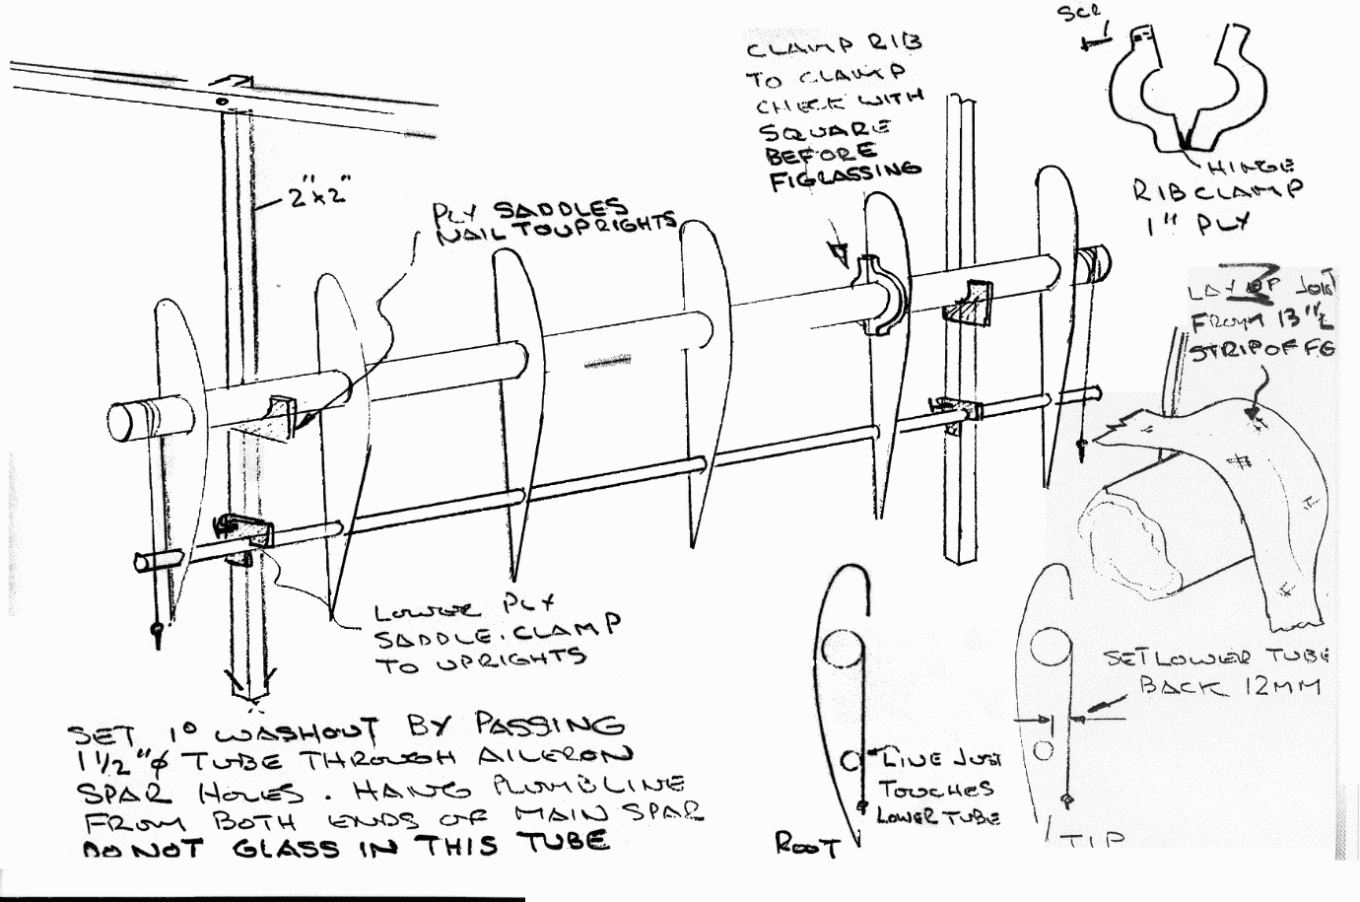
Wing jig

HE30TF tubing

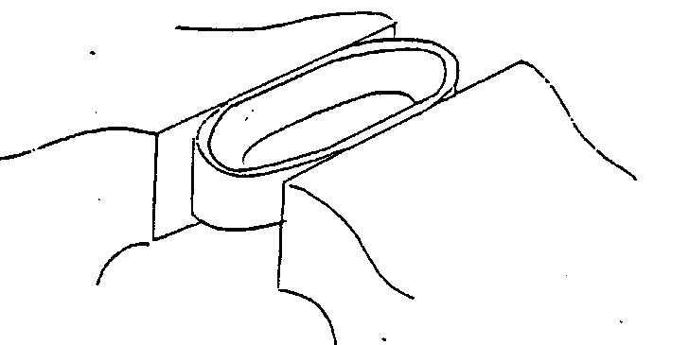

In the past a batch of tubing was found to be defective. When clamped in the vice a crack was heard. On examination the tube had cracked right through along its length indicating it was a defective bridge porthole extrusion
Test all tubes by cutting off a 10 mm piece from the end of the tube then crush it to half diameter in two opposite planes in the vice.
If defective the tube will split along its length.

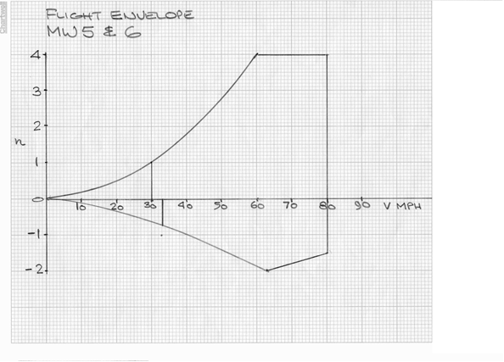
MW9 FLIGHT ENVELOPE

